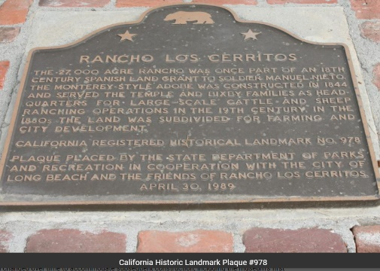
Rancho Los Cerritos Historic Site

Rancho Los Cerritos is a National, State, and Local Historic Landmark. The site is open to the public Wednesdays through Sundays, 1-5 PM.* Admission, tours, and parking are free. Donations support education and preservation programs.

The site's 1844 adobe includes 10 furnished rooms, plus several ‘sneak-peek’ rooms currently under restoration. The grounds include historic trees planted in the mid-nineteenth century, native plants and orchard trees that date to the early twentieth century, and fragrant blooms that have just emerged this week. Part of the Long Beach public library system, the non-circulating reference library and archival holdings emphasize California and local history. The site's Visitor Center houses exhibits, a short orientation film, and the museum shop's array of unique products.

*As the City’s ‘Safer at Home’ orders are adjusted, Rancho Los Cerritos’ gardens will reopen for active recreation, with extended hours on Saturdays. Visitors must comply with the site’s current safer-at-home guidance, which are based on City & State orders. Visitors will be able to stroll the site in a clockwise direction. Service animals are welcome to accompany their owner, but pets are not permitted. People showing any signs of illness are not permitted on the site.

What is Rancho Los Cerritos?
The 4.7-acre site of present-day Rancho Los Cerritos is located on land that was once populated by the Tongva people. The adobe sits near an ancient Tongva village, known as Tevaaxa’nga. The Tongva lived throughout the greater Los Angeles basin for thousands of years. These first Angelinos were primarily hunter-gatherers, but they also engaged in intra- and inter-tribal trade. Juan Cabrillo was the first European known to have made contact with the Tongva (1542), and Mission San Gabriel was the first Spanish settlement built in their region (1771).
Spanish soldier Manuel Nieto received a large land grant from Alta California Governor Pedro Fages (1784), which included 300,000 acres of land in today’s southwest Los Angeles and northwest Orange counties. Nieto's heirs sold 27,000 acres of that land (which had become known as Rancho Los Cerritos, or "ranch of the little hills") to Massachusetts-born John Temple (1843), a Long Angeles merchant. Temple hired Tongva workers to build the site’s two-story, Monterey-style adobe, which served as the headquarters for his cattle ranch, and installed a mayordomo (ranch foreman) to oversee his hide & tallow business.
Following a two-year drought that parched the entire state of California in the early 1860s, Temple sold Rancho Los Cerritos to Flint, Bixby & Co. (1866), which raised sheep on the property and employed dozens of Native American, Mexican, European, and Chinese workers, broadening the cultural profile of the region
After the Bixbys moved out of the adobe house (1881), they leased the property to a succession of tenants, farmers, and dairymen. During this period, the Bixbys also sold off most of their land for farms and towns. The City of Long Beach was eventually founded on this land (1884), as were the cities of Bellflower, Paramount, Signal Hill, and Lakewood. The Virginia Country Club bought the adjacent acreage (1919).
When Llewellyn Bixby Sr., son of Lewellyn Bixby of Flint, Bixby &Co., purchased the property from the family holdings (1929), he quickly set to work renovating the original adobe structure and landscaping the grounds (1930-31). Architect Kenneth Wing was hired to modernize the crumbling adobe, and landscape architect Ralph D. Cornell was commissioned to design and install an estate garden. Avis Bixby, Llewellyn’s widow, sold the property to the City of Long Beach (at half its market value) so that it would become a history museum, research library, and public garden (1955).
Today, visitors to Rancho Los Cerritos can see how diverse cultures and many peoples have contributed to the making of modern Long Beach. The site is maintained and operated by the Rancho Los Cerritos Foundation, in public-private partnership.

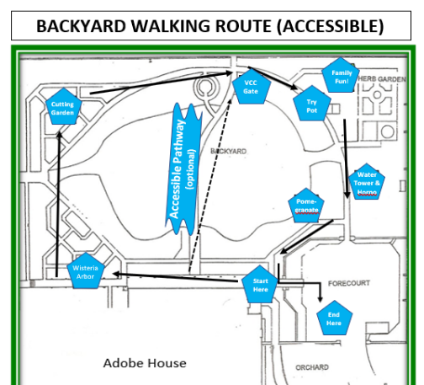
RLC Garden Tour Routes

Welcome! We are so glad you are here to enjoy the gardens!

The Rancho’s gardens provide both an enduring sense of serenity and a variety of seasonal surprises. The gardens feature both native and exotic plants, and they sustain native and migratory birds, butterflies, and other critters.

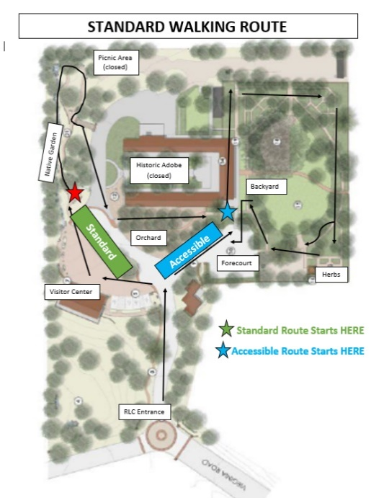
There are two clockwise walking tours through the Rancho’s gardens, the standard (not fully accessible) tour, which includes ascending a staircase from the native garden and a loose-dirt pathway through the orchard, and the accessible tour, which includes a brick walkway and packed-dirt pathways.

- Accessible Tour: After parking in the forecourt, you can enter the backyard through the green gates to start your tour in the alcove of the veranda. Depending on your personal circumstances, you can either follow the full backyard tour (heading next to the wisteria arbor) or cross from the central brick pathway that splits the lawns (heading to the country club gate).

- Standard Tour: Head north from the Visitor Center. Your tour begins at the entrance to the California native garden. After emerging from that one-way looping path via the staircase, you’ll pass the historic adobe and take the one-way orchard path to the backyard. Please circle the backyard in a clockwise direction, then end your tour in the forecourt. Passing the administrative building, you can head back to your vehicle. Or, time permitting, feel free to walk the route again.

A Little History about the Gardens…
John Temple built the historic adobe house (1844) and started planting the site’s first formal garden around that time. His colonial-style garden reflected his East Coast sensibility – and his adopted West Coast environs too. He ordered black locust, apple, plum, and peach trees to be shipped around Cape Horn for his new garden. He also planted five Italian cypress trees and fruit trees and vines that were common in Mexican California, including pomegranates, oranges, lemons, figs, grapes, and olives. Plus, he dug a well so that the people and the plants would have reliable access to fresh water.
Flint, Bixby & Co purchased the property (1866) and installed Jotham Bixby as ranch manager. He and his family moved into the Rancho Los Cerritos adobe. Their workers dug a new well and built a water tower with a windmill near the house to provide the family with better access to water. These improvements enabled the garden to prosper as well. The Bixbys spent many hours in the garden, as fondly recounted by Sarah Bixby Smith in Adobe Days (1925).
After the Bixbys moved out of the adobe house (1881), they leased the property to a succession of tenants, farmers, and dairymen. Row crops replaced many of the ornamental plants in the garden and pigs and chickens had the run of the backyard. During this same period, the Bixbys also sold off most of their land for farms and towns.
Jotham Bixby’s nephew, Llewellyn Bixby Sr., purchased the remaining five acres (1929) and embarked upon extensive renovations of both the house and gardens. Landscape architect Ralph D. Cornell was commissioned to design and install an estate garden. Cornell was an early proponent of the use of native plants. Rather than depend on annuals, he favored trees that would provide structure and seasonal color. With a nod to the site’s history, Cornell also incorporated John Temple’s try pot (a pot for rendering cow fat) and Jotham Bixby’s water tower into his design.
The City of Long Beach purchased the property (1955) and has continued to maintain the site, including its historic gardens, for public recreation, education, and research.

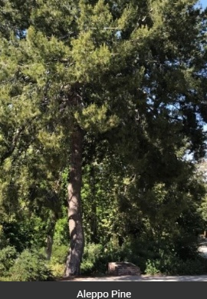
RLC Native Garden - Introduction

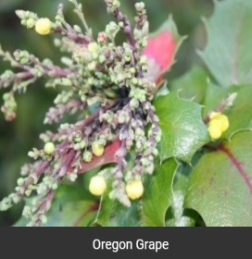
At the entrance to the Rancho's California native garden is an Aleppo Pine, a Mediterranean native well adapted to hot dry climates. The marker at the base of this tree commemorates the site’s status as California Registered Historical Landmark #978 (1989).
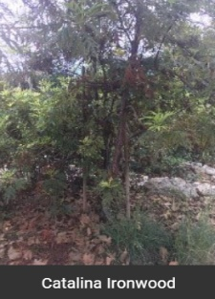
Near the first panel is an Oregon grape. Oregon grape leaves range in color from dark green to bright red. Its small yellow flowers in the spring become beautiful blue berries in the summer and fall. These plants were used by the Tongva for medicine, food, and dye.
Between the panels is a Catalina Ironwood. The ironwood gets its name from its very dense wood. The Tongva used the Ironwood’s trunk and branches for tools, arrows, harpoons and canoe paddles. Despite its density, the wood floats - an important consideration for coastal and island communities.
NOTE: This pathway is narrow, so it is to be navigated in a one-way direction during the current pandemic. If you continue past the pine tree, you will need to ascend a stairway to exit the California native garden.
DIRECTIONS: As you stroll further into the California native garden, you will notice two brightly colored panels explaining how the dry stream bed serves the site and its neighbors.

More Context: The California Native Garden
This portion of the 27,000-acre Rancho Los Cerritos was originally a sloping grade, falling away from the hilltop where the adobe was built. It was most likely filled with grasses and coastal sage scrub until landscape architect Ralph Cornell installed an estate garden for Llewellyn Bixby Sr. in the early 1930s. In Cornell's plan, this space was designed as a "buffer zone" - providing privacy for the Bixby family - between their property, the Virginia Country Club, and the growing Long Beach community. Cornell integrated both native and exotic plants into this area, although today it is planted primarily with California native plants.
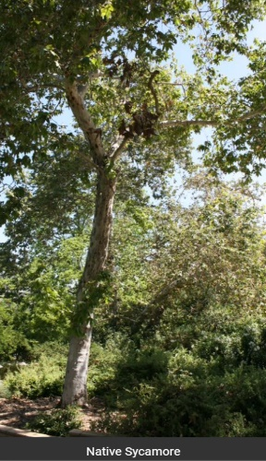
Much of this buffer zone has been changed over time to accommodate subsequent construction, including the museum’s first parking lot (1950s) and the site's Visitor Center (2012). The Rancho’s Master Plan (1999) recommended establishing a California native garden. Funded by the Port of Long Beach (2014), that installation preserved historic trees - both native and exotic - as part of the Port's pollution abatement program and also included a dry stream bed that absorbs rain runoff and protects the site’s down-slope neighbors.

RLC Native Garden - Sycamores & Ceanothus

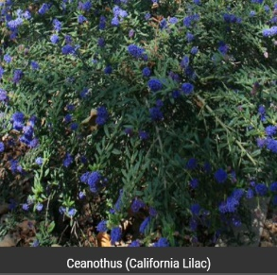
Native sycamores, planted by Cornell in the 1930s, are the keystone plant of this space. Their shady canopy provides a welcoming respite on a warm day. Cornell wrote at length about their “picturesque branching habit,” but he considered the bark to be their “most striking characteristic."

While strolling along this path, you will also notice tall shrubs with small dark green leaves and small clusters of purple-blue flowers. These are a hybrid Ceanothus (California Lilac) named Concha. The Tongva used the branches as digging sticks and their spring flowers as soap or shampoo.

DIRECTIONS: As you stroll further into the California native garden, please stay to the left along the loop.

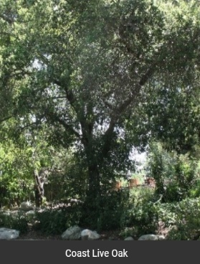
RLC Native Garden - Coast Live Oak

At the end of the loop, the Coast Live Oak provides more shade. Acorns were the primary staple of the Tongva as well as developing civilizations around the world. This is because oaks and humans thrive in the same kinds of environments.

After the fall harvest, the Tongva dried the acorns, leached them with water to eliminate the high tannin content, and ground them into flour. Once processed in this way, the acorns were safe for the Tongva to eat and could be cooked into mush or formed into flat cakes.

DIRECTIONS: As you make your way back around the loop, take the staircase on your left to exit the native garden.

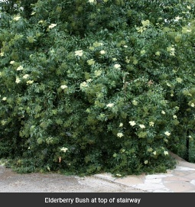

RLC Native Garden - Elderberry

At the top of the stairway is an Elderberry. The Tongva called this the “Tree of Music” because its branches and stems could be made into clapper sticks, flutes, and even whistles. In addition, its fruit added flavor to the Tongva diet and its flowers had medicinal properties.

DIRECTIONS: From the top of the stairs, the road leads in several directions: to the left is the picnic area (currently closed); to the right are the historic adobe (currently closed), the orchard path to the backyard (where the tour route continues), the Visitor Center (open for curbside pickup), and the parking lots.

RLC Orchard

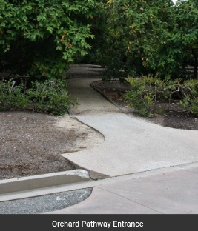
John Temple’s 1840s garden relied heavily on the fruit trees he could acquire locally, and it was enhanced by the seeds he imported.

In the 1930s, landscape architect Ralph Cornell honored that history and, in keeping with the golden age of gardening, added two orchards for the Bixby family. By locating the primary orchard on the south side of the adobe, Cornell ensured that the shady orchard trees would cool the hottest part of the house in warm months, while the sun would help warm and protect these trees during the cooler months.
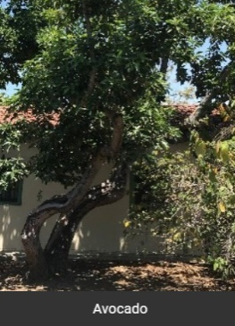
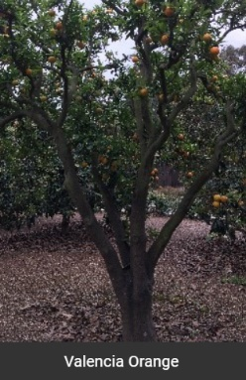
Standing sentry to the orchard path’s entrance are several tropical guava trees, and the hedge boundary is formed of sub-tropical guavas. Just inside the hedge are a trio of loquat varieties, which are native to Japan and were imported to California by the 1870s.
Three varietals of oranges were planted in the orchard, along with lemon, lime, tangerine, and avocado. It is interesting to note that Cornell propagated avocados while attending Pomona College to finance his education at Harvard in Landscape Architecture.
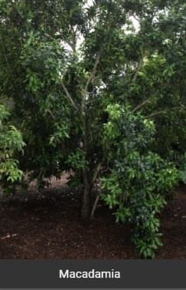
There are two macadamia trees in the orchard. These Australian natives did especially well in Hawaii and their popularity spiked during WW II, when service personnel passing through the islands acquired a taste for the rich nuts.
When the cherimoya was introduced to California from South America, it was discovered that the native pollinator could not survive in this climate. To produce quality fruit, each flower would have to be hand pollinated (which is sometimes done by commercial orchards, but not at RLC).
The sapote, which is native to central Mexico, has a pudding-like texture when ripe. Oddly enough, sapote and citrus belong to the same family.

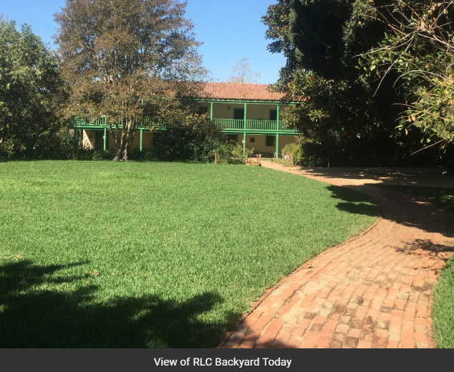
RLC Backyard - Introduction

If only these plants could talk! Several of the trees in this area were planted when John Temple built the adobe, more than 175 years ago. Some of them were planted when Jotham Bixby owned the property in the 1880s. The majority of the garden is based upon the 1930s landscape installed by Ralph Cornell.

In the 1840s, Temple added a formal two-acre garden behind his adobe with raised beds and cultivated plants, which are rare in arid Alta California, and he enclosed the space with a tall redwood fence to keep his livestock out.

In the 1930s, Cornell Changed the shape of the garden. The Bixby family also added a forecourt for guest parking, and they installed a doorbell outside the gate, which ensured that visitors entered the landscaped garden before the home. For generations this space has served as a place for respite and recreation and continues to do so today.

More Context: The Backyard
John Temple's workers constructed a grand two-story adobe as the headquarters for his cattle ranch (1844), but the adobe never became his primary residence. He continued to live in the pueblo of Los Angeles. Yet here he installed a colonial-style garden reflecting his New England roots that quickly became quite the showplace. Temple requested seeds from Massachusetts, but the majority of plant material was sourced locally – all of it exotic to the Yankee – including Mission grapes, figs, pomegranates, and oranges.
When Flint, Bixby & Co. purchased Temple’s 27,000-acre rancho (1866) for $20,000, their deed included the 10,000 square-foot adobe, the brand, and the remains of Temple’s two-acre garden. Southern California had suffered a devastating flood and two-year drought earlier in that decade, which would certainly have impacted Temple’s garden. Unlike Temple, Jotham Bixby made the adobe his family home. He introduced two Moreton Bay Fig trees (1880 ca.) into the landscape, shortly before moving to town and leasing the property to tenants. Those fig trees eventually grew together, into one spectacular specimen that is now considered the showpiece of the backyard.
The tenant period (1880s-1920s) saw a dramatic change in the backyard. Since the tenants needed to provide food for their families, row crops replaced any remaining ornamentals. There were also pigs apparent in some of the old photos, and a chicken coop was referenced in at least one oral history of the period.
Llewellyn Bixby Sr. purchased the remaining 4.7-acre parcel from the family holdings (1929) and hired landscape architect Ralph Cornell to design an estate garden. Bixby had no doubt heard family stories about his uncle's garden, and Cornell embraced the concept of preserving mature trees and honoring the family legacy in his landscape design.
Today, the Rancho Los Cerritos backyard is a serene, historic setting that entices visitors to stroll, to explore, and to return time and again. It is also a popular venue for weddings, celebrations, and public events.

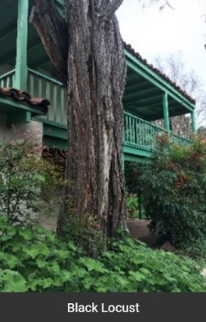
RLC Backyard - Black Locust

Starting at the southern end of the veranda (where there is a small alcove), your first stop in the backyard features a Black Locust tree. This type of tree, which was grown from seeds that Temple imported in the 1840s, once lined the perimeter of the two-acre garden. With their fragrant springtime flowers, the trees were equally popular with the Bixbys of both the 1860s/1870s and the 1930s.

The Black Locust here, adjacent to the house in the alcove, is an off-shoot of one of Temple’s trees. During the 1930s renovation, the Bixbys chose to save the tree - by shaving the corner of the 1844 adobe - to accommodate its roots. It continues to bloom every spring.

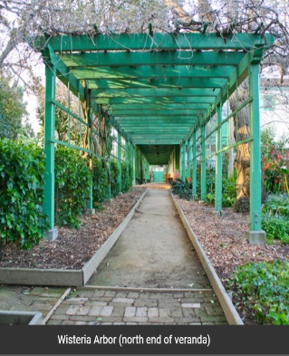
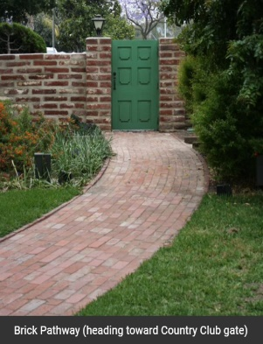
DIRECTIONS: From the Black Locust, stroll north along the veranda (covered porch) to explore the backyard in a clockwise direction, heading next to the Wisteria arbor at the north end of the veranda. If to follow the more accessible route, take the brick pathway that starts half-down the veranda and divides the lawns heading toward the Virginia Country Club gate.

NOTE: The 1844 adobe house is temporarily closed, due to Covid-19 restrictions, but please come back soon to see the inside.
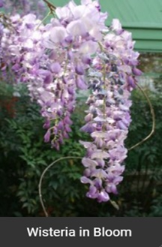

RLC Backyard - Wisteria Arbor

In Temple’s time there were two peaked arbors, one on either side of the veranda, that supported grape vines. While these were only a memory by the 1930s renovation, Cornell designed a single new wisteria arbor for the estate garden. When the wisteria vines bloom in the spring, fragrant clusters of purple flowers draw many visitors - and, of course, are reminiscent of those long-ago purple grapes.

DIRECTIONS: After exiting the wisteria arbor, head into the cutting garden, which is located to the northeast of the wisteria arbor and distinguished by raised planting beds.

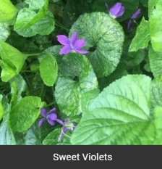
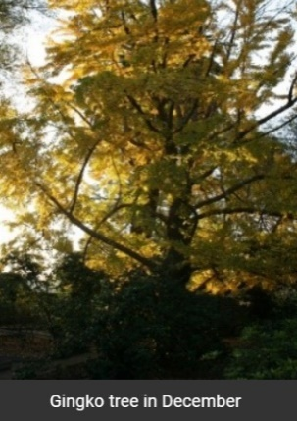
RLC Backyard - Cutting Garden

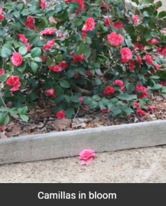
Typical among estate gardens of the 1930s, Avis Bixby's cutting garden provided fresh seasonal flowers. When originally designed, this was a sunny space. As the Moreton Bay Fig in the central backyard grew, however, it changed this area from sun to shade. The plants here are now shade-tolerant perennials appropriate to the period, including sweet violets - one of Avis’ favorites. Further along the pathway, camellias have replaced most of Avis' roses.

Not only does the Moreton Bay Fig now shade this area, but the Bixbys also added a Ginkgo tree after Cornell has installed the landscaping. While the camellias certainly add winter color, the real show is in December when the Ginkgo itself changes color. An unusual species, Charles Darwin called it a “living fossil” because it has survived since the Carboniferous Period (about 300 million years ago)!

DIRECTIONS: From the Ginkgo tree, continue along the eastern perimeter pathway (which runs parallel to the Virginia Country Club), for a stunning view of the central backyard.
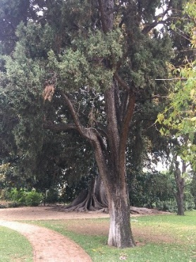

RLC Backyard - Country Club Gate

Standing by the green gate to the Virginia Country Club, you'll have a sweeping view of the central backyard and 1844 adobe house. This gate served as Llewellyn Bixby Sr.’s personal entrance to the Virginia Country Club (1922), where he was an avid golfer and board member.
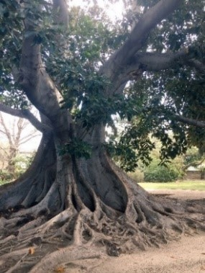
On your right is one of three remaining Italian Cypress trees from Temple’s 1840s garden. This specimen (left) has been designated an “Exceptional Tree of Los Angeles County” for its age and beauty. The tree that practically overwhelms the garden – and the adobe house – is a Moreton Bay Fig (right), which was planted in the 1880s.

Note: The fig tree’s buttressing root system is not a safe area to climb, play, or take photos. Please stay off its roots.

DIRECTIONS: Please continue along the eastern perimeter pathway, toward the southeastern corner of the garden to see Temple's try pot.

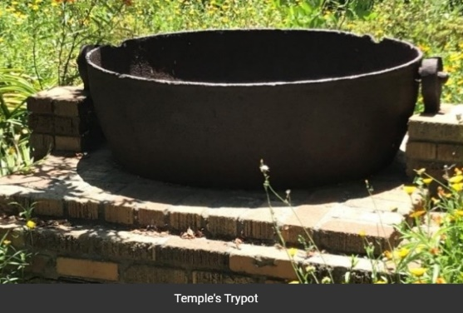
RLC Backyard - Temple's Try Pot

Under the Spanish & Mexican flags, Alta California’s economy was based primarily on the hide & tallow trade and cowhides were known as “California banknotes." The hides were shipped around the horn of South America to England and New England, where they were made into saddles, boots, luggage, and other leather goods. The cow fat, or tallow, was rendered in iron cauldrons (or try pots), and the process was called "trying." Tallow was used domestically in the manufacture of candles and soap.

Incorporating the site’s history into his landscape design, Cornell placed Temple’s try pot (which was unearthed during the renovation) in Avis Bixby’s cutting garden as a unique sculptural element. This storied focal point is a tempting photo opportunity (as it was when Llewellyn Bixby’s grandchildren visited in the 1930s), but the iron try pot is in fragile condition, so please do not let anyone climb inside. The City moved Temple’s try pot to its current location several decades ago.

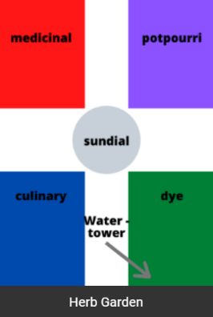
RLC Backyard - Herb Garden - Especially for Families!

Planned and planted by volunteers from RLC and the Jr. League of Long Beach in the 1980s, the herb garden supports our award-winning school tour program. It is divided into four sections – culinary, medicinal, dye, and potpourri – to show how the herbs are useful in different ways. The four quadrants surround a central sundial, which was dedicated to Jotham Bixby in the 1920s.

Can you guess which bed is which? Bonus Question: What time it is?
Hints for identifying herb garden beds:
- Aloe is used for burns, and rosemary for rinsing wounds (medicinal).
- Bay leaves and fennel help flavor meats and sauces (culinary).
- Indigo can color cotton blue, while tansy can color wood green to protect it from termites (dye).
- Lavender repels wool moths, even if humans find it soothing (potpourri).
Hints for bonus question: If the sun is shining, look closely at the sundial. Note: depending on the season, you may need to add/subtract an hour for daylight savings time.
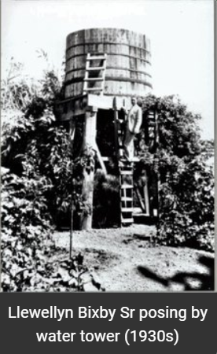

RLC Backyard - Water Tower & Horno

Water and food are central to daily life. When Temple’s workers lived in the adobe, they pumped water from the nearby river utilizing a water ram. This was effective until the 1860s, when a severe drought caused the river level to drop, so they dug a well in the garden and used a well sweep to pump water into a cistern.

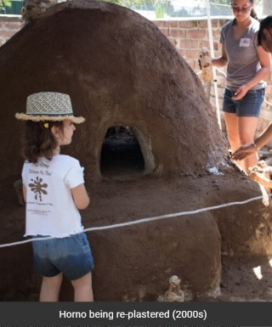
When Jotham Bixby and his family moved into the adobe in 1866, they dug a new well and built this raised water tower. They also added a windmill to the water tower, to help pump the water from the well up into the tank. In the 1930s, Rancho Los Cerritos was finally connected to the City's water system and electric grid, but Cornell incorporated the old water tower as another garden element.

The Spanish word for oven is horno. The horno you see here (whitewashed, beehive-shaped structure) was built of adobe bricks by volunteers in 1988, to resemble the one that was once located near the ranch’s kitchen in John Temple’s time. Temple’s horno was used for baking by the Bixby’s Chinese cook, Ying, in the 1870s, although he also had a wood-burning stove in the house. This horno is used for special occasions, and it must be re-plastered with mud and then whitewashed annually.

DIRECTIONS: Follow the pathway to the north (toward your right), as you approach the horno, which will take you back toward the historic adobe building.

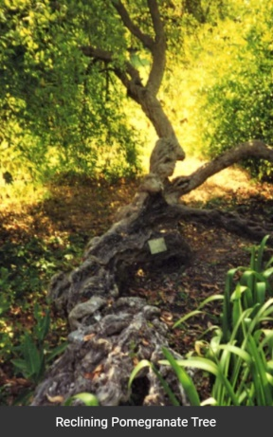
RLC Backyard - Pomegranates

Pomegranates were popular in Alta California's mission gardens, and that is likely the source for Temple’s trees. Three pomegranate trees remain from the 1840s, two in the backyard and one in the forecourt. As one the these aged, it reclined (see photo). Where its trunk touched the earth, new roots have formed.

John Temple's garden dates to the same decade as Queen Victoria's reign; she ascended to the throne in 1841. Interestingly, the people of that era - whom we today refer to as "Victorians" - had a language represented by flowers; the pomegranate’s flower was said to represent "mature beauty." How appropriate for this reclining beauty!

DIRECTIONS: Exit the garden through the forecourt gates (on your left as you approach the adobe’s veranda again).

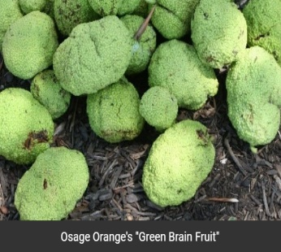
The RLC Forecourt

Just outside the gates is a plaque that shows the dividing lines between two portions of the original Spanish land grant to Manuel Nieto (1784) known as Rancho Los Nietos grant: Rancho Los Cerritos & Rancho Los Alamitos.

The tallest tree in the forecourt is an Osage orange, which dates to Temple’s 1840s garden and is native to Louisiana and Eastern Texas. The Osage people harvested its roots, bark, and fruit to dye textiles and provide wood for tools and weapons. Popular in the Midwest as a hedge to mark property boundaries since the 1800s, the Osage is unusual in Southern California. In midsummer to early autumn, the falling fruit creates astonishment for Rancho visitors who say it looks suspiciously like a “green brain.”

Thanks for Visiting - Come Back Again!
Some of Rancho Los Cerritos’s Other Historically Informed Experiences
House Tours: Once the City’s “Safer a Home” orders permit, the historic adobe will be open for self-paced tours, too.
Exhibitions: Curated cultural exhibitions celebrate the diversity of the people who have called Long Beach home for over 5,000 years. The current exhibit, “Tevaaxa’nga (Te-vaah-ha-nga) to Today: Stories of the Tongva People,” explores the history and culture of the Tongva (Gabrielino). It is now virtually on display on our website due to Covid-19.
Specialty Programming: Rancho Los Cerritos connects the community to its local and regional history through a wide array of programs designed to engage people from all walks of life. Creation Station, Bird Walks, Summer Concerts, Mud Mania, Home for the Holidays, and Storytime provide a community space for visitors to enjoy.
Adobe Days Revisited: The site’s award-winning field trip program serves nearly 6,000 fourth-grade students each year. Costumed docents use immersive theater techniques to demonstrate and teach what Rancho life was like, circa 1878.
Long Ago Long Beach: The site’s award-winning outreach program features highly interactive workshops that bring the Rancho experience to more than 1,000 LBUSD second- and third-grade students annually. Long Ago Long Beach Online is now accessible on the website, including two downloadable activity booklets and instructional videos.
Volunteering: Volunteers are the life-blood of most museums, and Rancho Los Cerritos is no exception! Volunteers greet visitors, lead tours, assist with collections care, help maintain the gardens, staff public programs and events, conduct historical research, and more. College interns work on special projects, under the direction of the site’s historical curator, education director, horticulturist, publicist, and/or fundraising director. The site also offers volunteering opportunities specifically for high school students, who can earn valuable community service hours while developing career/college readiness skills, whether during the school year or in the summer. Get involved!
California Research Library: Containing more than 3,000 books on California history, both rare volumes and current publications, the research library is a non-circulating reference center for scholars and students alike. In addition to finding aids available on site, the books are cataloged through the Long Beach Public Library. Appointment required.
Private Rentals: Rancho Los Cerritos has lovely spaces available for a wide array of events, including weddings, baby showers, anniversary parties, corporate retreats, book club meetings, and more. Pricing varies by date, time, and size of meeting.

