“Adobe Days Revisited”

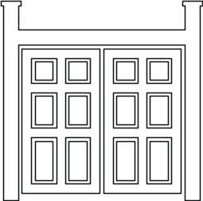

Student Readings & Activities

Classroom teachers have permission to reproduce this document for students to use.

Rancho Los Cerritos Historic Site

4600 Virginia Road, Long Beach CA 90807
(562) 206-2030
www.RanchoLosCerritos.org

This is a blank page.

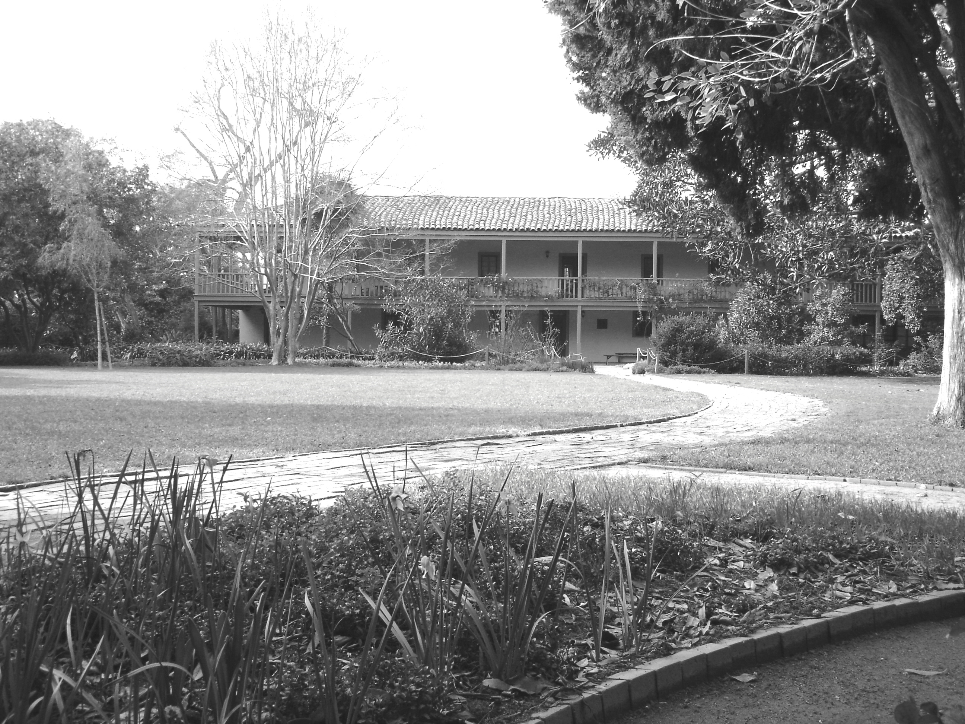

Rancho Los Cerritos Historic Site

4600 Virginia Road, Long Beach, California 90807
Phone (562) 206-2040 * www.RanchoLosCerritos.org

Rancho Los Cerritos Historic Site is a museum owned by the City of Long Beach and operated by the Rancho Los Cerritos Foundation. The 1844 adobe house and landscaped gardens echo with the rich history of Spanish, Mexican, and American California and with the families who helped transform Southern California from its ranching beginnings into a modern, urban society. The site offers unique educational experiences throughout the year, including house and garden tours, concerts, festivals, camps, and more.

As noted in your confirmation, we anticipate that you will prepare your students in advance for their “Adobe Days Revisited” field trip. Doing so helps ensure that your students will have the best possible educational experience. This packet of student readings and classroom projects, along with the film on our website, should help. We have also made Adobe Days Revisited: Teacher Resource Manual available in every LBUSD elementary library, which includes several dozen additional activities; our TRM was developed in conjunction with LBUSD master teachers to meet state curriculum standards for History & Social Science.

We anticipate that this packet of readings and activities will help reinforce and underscore the significance of the information your students read about in their history textbook and the activities they will experience when they visit the site. You are welcome to reproduce any of the readings for student use, and we hope that you will let us know how well they work for you and your students!

We also have two award-winning educational trunks filled with artifacts, maps, and images that you can borrow to ensure that your students are even better prepared for their field trip. Call the Rancho’s Education Office for more information about borrowing either “Handling History: Exploring Daily Life on a Nineteenth-Century Cattle Ranch” or “Through Children’s Eyes: Rancho Life with Harry & Sarah.” They each come with an extensive resource manual that includes classroom activities plus teacher and student readings.
This is a blank page.
A Short History of Rancho Los Cerritos

Long ago, the land surrounding present-day Long Beach was home to the Tongva. These native people lived off the land, gathering plant materials for food, tools, and shelter. They also hunted animals for food and clothing. Starting in 1769, the Spanish government sent soldiers and missionaries to Alta California (present-day California) to establish pueblos (cities), missions (churches), and presidios (military forts). Spanish missionaries taught the Tongva new skills that they needed at the missions, like adobe construction, blacksmithing, cattle and sheep ranching, candle and soap making, and planting and harvesting agricultural crops. In addition, the missionaries taught the native people their Spanish language and tried to convert them to their Catholic religion.
In 1784, the Spanish government began granting land to Spanish citizens living in Alta California. One of these large tracts of land was granted to a Spanish soldier named Manuel Nieto, as a reward for his many years of military service. Nieto raised cattle and horses on the land until he died in 1804. His land was then divided among his children. His daughter, Manuela Nieto de Cota, received the part that was called “Rancho Los Cerritos.” She and her family raised cattle on the property, and they lived in a small adobe home that they built.
A Massachusetts-born businessman named John Temple bought the land from Manuela Nieto de Cota's family in 1843. Mr. Temple built a large adobe house on his property. He had about fifteen thousand head of cattle, which he raised for the “hide and tallow” trade. The hides were used to make leather goods like boots and saddles, and the tallow (fat) was used to make soap and candles. Most of the meat spoiled because there was no refrigeration (nor electricity) in those days. There were not enough people living in this area to eat the meat fresh. During the Gold Rush, which began in 1849 (following the discovery of gold in 1848), cattle ranching became far more profitable because there were thousands of hungry miners to buy the beef. In 1866, Mr. Temple sold the ranch and retired.
The new owners, Flint, Bixby & Co., purchased the land for their sheep ranching business. Jotham Bixby and his family moved into Temple’s adobe house and managed Flint, Bixby & Co.’s sheep ranch. The Bixbys lived at Rancho Los Cerritos until 1881, when they moved to Los Angeles. At that time, Mr. Bixby’s oldest son began selling off portions of the rancho to people who wanted to raise dairy cows, plant crops, or start new cities. The cities of Long Beach, Bellflower, Lakewood, Signal Hill, South Gate, Paramount, and Downey were founded on former Rancho Los Cerritos land.
By 1929, the adobe ranch house was in bad shape. Its adobe walls had not been whitewashed in many years. Its roof leaked, and its stairways were crumbling. Jotham Bixby’s nephew, Llewellyn Bixby Sr., purchased the remaining property and restored the house. He added electricity, heating, and indoor plumbing. He and his wife moved in on March 17, 1931, and his grown children often came to visit with their families. After he died, the property was sold to the City of Long Beach and turned into a museum. Rancho Los Cerritos Historic Site opened to the public in 1955.

Comprehension Questions

Why did John Temple buy Rancho Los Cerritos?
Do you live on land that was once part of Rancho Los Cerritos?

Reflection Question

Why do you think some old buildings become museums while others do not?

Create a Rancho Timeline

Materials:
Student Reading: “A Short History of Rancho Los Cerritos”
Student Worksheets: Rancho Los Cerritos Timeline
Rancho & California Timeline
Timeline of Your Life
Pencils, markers

Approach:
After students read “A Short History of Rancho Los Cerritos,” the class should discuss the concept of timelines to ensure that all students understand the purpose of representing significant dates and events in this format. Be sure to explain that timelines can be used to represent events that happened over a long span of time, or they can be used to represent events that transpired over just a few years. Timelines can also be used to describe the lives of people during a single generation or of families over many generations.

Once students have created their own “Rancho Los Cerritos Timeline” (1784-Present), they can compare their 200+ year timeline to the more circumscribed “Rancho & California Timeline” (1780-1850). As they see what was happening in California during important points in Rancho Los Cerritos’ history, students will learn that timelines can also tell two stories at once.

Task:
After reading about the history of Rancho Los Cerritos, students will use the information they have learned to complete their own “Rancho Los Cerritos Timeline.” Students can then compare their timeline to the “Rancho & California Timeline.”

Follow-up activity:
Students can create a timeline of their own life, starting with the year they were born and continuing through the current year. They can ask their parents to help them identify significant personal events that took place in specific years of their lives. They can illustrate their personal timeline with drawings or photographs.

Rancho Los Cerritos Timeline
Use the information you read in “A Brief History of Rancho Los Cerritos” to complete the timeline below.
Indicate one thing that happened in each of these years related to Rancho Los Cerritos.

1784 1804 1843 1866 1881 1931 1955 Present

Rancho Los Cerritos Timeline

Manuel Nieto was granted John Temple Bixby family RLC became a My class learned about
land by the King of Spain purchased RLC moved to LA museum Rancho Los Cerritos

1784 1843 1881 1955

1784 1804 1843 1866 1881 1931 1955 Present

Manuela Nieto de Cota Flint, Bixby & Co Llewellyn Bixby
inherited Rancho Los Cerritos purchased RLC moved into RLC
1804 1866 1931
Rancho & California Timeline

Important Dates in Rancho Los Cerritos History

Manuel Nieto was granted Manuela Nieto de Cota John Temple Flint, Bixby & Co
land by the King of Spain inherited Rancho Los Cerritos purchased RLC purchased RLC

1784 1804 1843 1866

1780 1790 1800 1810 1820 1830 1840 1850

1781 1821 1846-48 1849+
Pueblo of Los Angeles Mexico gained Mexican- Gold Rush
was founded independence American
from Spain War
1850
Statehood
granted

Important Dates in California History

Timeline of Your Life

Make a timeline of your life. Each square should represent one year of your life. Begin with the year of your birth. Then fill in the next nine or ten years (depending on your age). Think of at least three major events that have happened in your life, and find out the years in which they happened. You might include such events as when you started school, joined a sports team, or took a memorable vacation. Draw a line between the event and the correct year. Write a short sentence about each event on the lines provided. You can also draw a picture or paste photographs of the events on a separate sheet of paper!

Timeline for ____________________________________________.
(name)

Year  _______ | Year  _______ | Year  _______ | Year  _______ | Year  _______ | Year  _______ | Year  _______ | Year  _______ | Year  _______ | Year  _______ | Year  _______

I was born on Event: Event: Event:

______________________
(date)

at

______________________
(hospital or location)

in

______________________
(city, state, and/or country)

Event: __________________ Event: Event:

_______________________

_______________________

_______________________

_______________________

_______________________

_______________________

Event: __________________ Event: Event:

_______________________

_______________________

_______________________

_______________________

_______________________

_______________________

Event: __________________ Event: Event:

_______________________

_______________________

_______________________

_______________________

_______________________

_______________________

What is a Land Grant?

A “land grant” is a gift of land made by the government to an individual, often as a reward for military service or to encourage settlement in a particular area. Beginning in the 1780s, land grants were awarded by the King of Spain in Alta California to attract new settlers and bring Spanish cultural and religious traditions to native populations. These land grants were specifically intended to encourage people to raise livestock, like cattle, sheep, and hogs. They were called “ranchos.”
To obtain a land grant, a person had to be a loyal Spanish citizen. In addition, he had to submit a petition containing his name, religion, residence, occupation, family size, and number of livestock, as well as a hand-drawn diseño (map) and a written description of the desired land. If the petition was approved, the grantee was required to live on the property for at least four years, to stock the land with cattle, and to make improvements to the rancho like building a house and planting crops. If these requirements were not met, the land would revert to the King of Spain.
Manuel Nieto’s rancho was among the first land grants in Alta California. He received 300,000 acres of land in 1784, while he was a soldier at the Mission San Gabriel. He raised cattle on the property, which was known as Rancho Los Nietos. After he died, his daughter Manuela received the 27,000-acre portion known as Rancho Los Cerritos. She and her husband, Guillermo Cota, built a small adobe house on the property, and they continued to raise cattle. Manuela Nieto de Cota’s descendants later sold Rancho Los Cerritos to John Temple (1843), who in turn sold it to Flint, Bixby & Co (1866).

Reading Comprehension Questions
What information must a land grant petition include?
When was Manuel Nieto’s land granted?
Create A Diseño

Materials: Student Reading: “What is a Land Grant?”
Pencils and markers (recommended: quill pens and ink)
Clipboards (1 per group)
Brown paper cut into 12" x 12" squares (or larger)
Consistent lengths of rope (recommended: 10 yards each)

Approach: When Mexico assumed control of Alta California in the 1820s, the new government continued to make land grants to local citizens. There were main two requirements: to be (or become) a Mexican citizen and to belong to the Catholic Church. Persons who met these requirements could petition the government for land; if successful, they were required to build a house on the land, maintain a herd of 150+ cattle, and create a diseño. The ranch land also had to be located at least 12 miles from a pueblo, mission, or native village.

What is a diseño? It is a nineteenth-century ranchero’s hand-drawn map of his property boundaries. To measure the land, the ranchero typically used a long rawhide rope, stretching it from an initial point to a second point, then from the second point to a third, and so forth. He needed helpers to hold each end of the rope and to record the measurements. The ranchero also needed some basic artistic ability, so that he could represent various geographic and natural elements on his map (e.g. rivers, mountains, trees, boulders, etc).

Task: Small groups of students will create diseños of their schoolyard. Before starting this activity, students will need to learn what a diseño is, what kinds of information a diseño should include, how to measure with a reata (rope), and how to calculate area. Each small group of students will then create a diseño by measuring the distances between various landmarks they see in their schoolyard (e.g. play structure, trees, buildings, etc) and then drawing them on their map. Finally, the students can calculate the total area and the area per student.
Directions:

- Gather and prepare all supplies.

Here are some tips:

To make craft feathers into quill pens, cut the tip of the stem at a cross angle and make a small length-wise slit from the point.

Craft feathers, various colors of ink, and shallow plastic trays can be purchased from most art supply stores (Michael’s, JoAnn’s, etc).

Use the backside of paper grocery bags (or brown craft paper) for the maps, since this kind of paper is sturdier and looks more “authentic.”

- Have your students read “What is a Land Grant?” Discuss the purpose and significance of land grants and diseños.

3. Explain any specific instructions for gathering data. For example, students will need to know what area they are expected to measure (examples: the field, the playground, or the whole schoolyard), as well as the kinds of landmarks their diseño should include (examples: structures, fencing, trees, tables, and/or benches).

4. Assign students to small groups of 3-4, provide each group with the necessary supplies, and set them to work.

- When the students return to the classroom, ask them to trace over the pencil lines on their map. They can use markers or quill pens. If the latter, they should first practice writing with the quills on scrap paper, so that they become familiar with how these “old fashioned ink pens” work.

- Finally, students can calculate the total area they measured by multiplying the (average) length of the space by the (average) width. They can also calculate the area per student by dividing the total area by the number of students who use the schoolyard.

Here Come the Forty-Niners!

On January 24, 1848, James Marshall was inspecting the water flow in the new sawmill he had built for his boss, John Sutter, when he noticed something sparkle in the stream. It was a golden nugget about the size of a pea. Sutter wanted to keep the discovery quiet, but it was just too big a secret to keep. Before long, a San Francisco newspaper published the news, and within a few months the New York newspapers were reporting that there was gold for the taking in California. President James Polk confirmed the discovery in an address to Congress on December 5, 1848. Within a short time, tens of thousands of people from around the world were making their way to California’s gold fields!
The first prospectors came from California’s pueblos and ranchos, as 80% of the local male population headed to the mountains. From the vicinity of Monterey, the capital of Alta California, a thousand men were said to have left for the mining areas within a week. By the summer of 1848, people were arriving by land from Oregon and northern Mexico and by sea from the Sandwich Islands (Hawaii). As the news continued to spread, miners came from Peru, Chile, China, and the eastern United States. It seemed like there was plenty of gold for all, with fresh discoveries being made daily. The gold seekers became known as “forty-niners” because more than 80,000 prospectors poured into California that year alone (1849).
One of the 49'ers was Benjamin Flint, who arrived in the gold mining town of Volcano, California, from his native Maine. Two years later, his brother Thomas Flint and his cousins Lewellyn and Amasa Bixby joined him. Two more of Lewellyn’s brothers, Jotham and Marcellus Bixby, arrived in California in 1852. Lewellyn Bixby tried his luck in the gold fields for about a week before going to work in a butcher shop. Unlike his brother, Jotham Bixby remained in the gold fields for three years. Meanwhile, Lewellyn Bixby and his Flint cousins purchased nearly 2,000 sheep and started a sheep ranching business in northern California. In 1866, Flint, Bixby & Co. expanded their sheep ranching operations when they purchased Rancho Los Cerritos from John Temple. They asked Jotham Bixby to manage it.

Reading Comprehension Questions

Who were the “forty-niners,” and how many of them were there?
When did Jotham Bixby come to California, and how did he make his living?

Rancho Los Cerritos Cross Word Puzzle

Adobe Foreman Horno Manuel Nieto Stereoscope
Blacksmith Forty Niners John Temple Mission San Gabriel Tallow
Cattle Herbs Jotham Bixby Shears Tongva
Diseno Hide Land Grant Sheep Vaquero

Across
3. Spanish word for cowboy
4. Sun-dried brick made of clay soil, sand, straw, and water; can also refer to a building made of these bricks
7. Man who repairs wagon wheels and fits horseshoes
9. Closest mission to Rancho Los Cerritos
11. People who rushed to California after gold was discovered at Sutter’s Mill in 1848
13. Spanish word for an outdoor oven made of adobe
14. Ranch animal that says "baaa"
17. Old-fashioned photograph viewer that makes images appear three dimensional
18. Man who built the Rancho Los Cerritos adobe in 1844
19. One of the first Spanish soldiers to receive a land grant in Alta California from the King of Spain
Down
1. Ranch manager
2. A herd of cows, bulls, and steers
5. Hand-drawn map of geographic features and property boundaries
6. Plants used for medicine, cooking, fragrance, etc
8. A tract of land given by the government
10. “Scissors” used to clip the wool of a sheep
12. Cow fat used to make soap and candles
15. Cow skin used to make boots and saddles
16. Man who owned Rancho Los Cerritos in the 1870s
20. Name of the local Native American tribe



